Team 2 - Foodbulous Revamp
First Milestone Proposal

- INTRODUCTION
介绍产品，公司，组
Innopage: https://www.innopage.com
Design team: According to Keith, the App was designed and developed by an intern team where people with diverse backgrounds and want to present their own ideas in one product. Now the team members have left Innopage.

- MARKET ANALYSIS — RIVAL
OpenRice is the industry key player of Hong Kong food review websites. After meeting with Keith, it is ensured that Foodbulous does regard OpenRice as its main rival.
2.1 Overview
- More than 3 million monthly users
- 83 million-page views,
- More than 450,000 registered members
- 500,000 reviews.
- Ranks 29th on the entire Hong Kong website, with about 66% of traffic coming from Hong Kong.
- Has more than 41,000 restaurants in Hong Kong, Macau and Shenzhen (Hong Kong accounts for 21,000)
2.2 Problems
- For restaurant seekers
- the restaurant recommended by OpenRice is not delicious.
- Too many comments are made by ‘打手’.
- The OpenRice app is full of advertisements, affecting users' feeling.
2）For reviewers
- They need to wait for ‘moderate’, and they don't know how long to wait.
- Their bad reviews may be blocked.
- The KOL group on OpenRice has been finalized, and it is difficult for newcomers to become famous.
As Keith said, no one likes OpenRice. This gives Foodbulous a chance to solve the problems brought by OpenRice and meet the needs of users that OpenRice can't meet.

- PRODUCT ANALYSIS
3.1 Mission
“How to find good food” is a common question in everyone’s daily life. Foodbulous is trying to provide a reliable way to help people explore best dishes and find what they want to eat. Through Foodbulous, foodies will not only find it genuine while interacting with friends, but they may restore beliefs and passions towards delicious food as well.

3.2 SWOT analysis

Strengths  - Emphasis on the interactions between friends;  - Few fake reviews;  - Has innovation point: "Deck(食組)" function aims to help users better manage and browse their favorite restaurants;  - Support small restaurants, no recommendation fees;  - Passion for exploring the restaurant's story. | Weaknesses  - The database is incomplete and the update is slow;  - The app is not user-friendly;  - Lack of customer data;  - Single channel for publicity.
Opportunities  - Restaurant finder app market has a lot of room for development;  - Users are tired of OpenRice's false reviews;  - The successful experience of the Mainland can be applied to the Hong Kong market. | Threats  - Fierce competition in the industry;  - Similar apps whose main design idea is the same as Foodbulous.

3.3 USP
1) Recommendations based on friends’ reviews: More reliable and persuasive compared to information provided by restaurants
2) Interactions with other foodies: through likes on food reviews (but currently the engagement is quite weak)
3) Collections of favorite food or restaurants: decks (but the concept is actually too complicated to understand)

3.4 Product Features
There are five major pages on Foodbulous:
News Feed(動態消息), Discover(探索), Restaurant(搜尋餐廳), Foodie(食家) and Profile(我的食鑑)
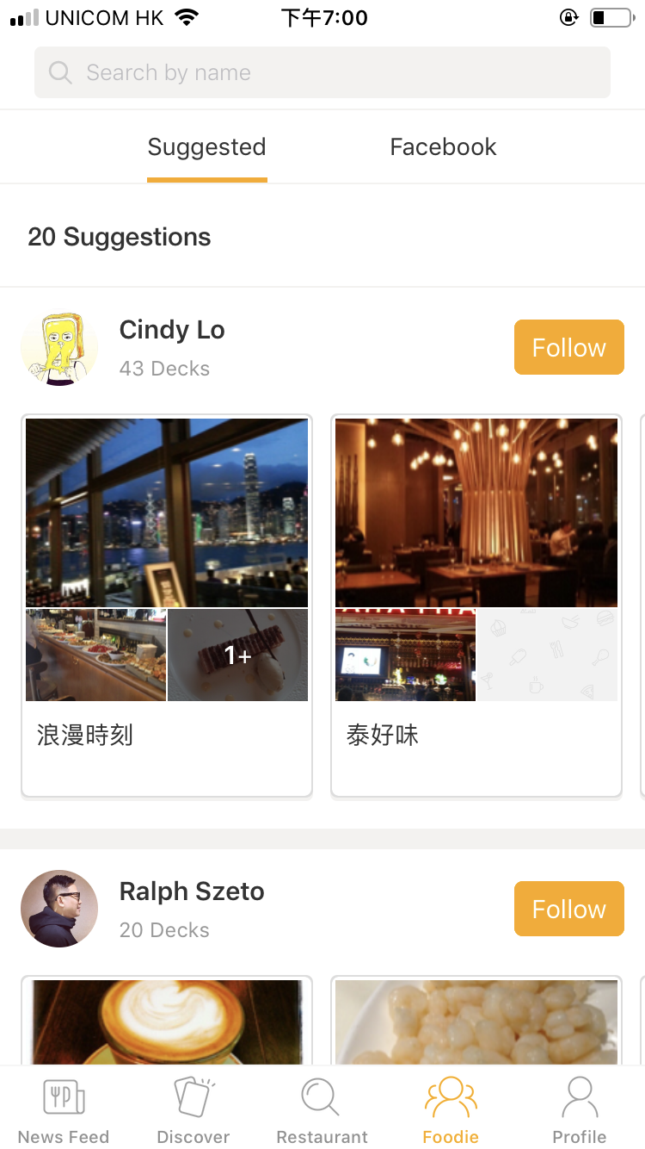
Other important pages include Login page and Restaurant single page.

1) Login and Sign up Pages
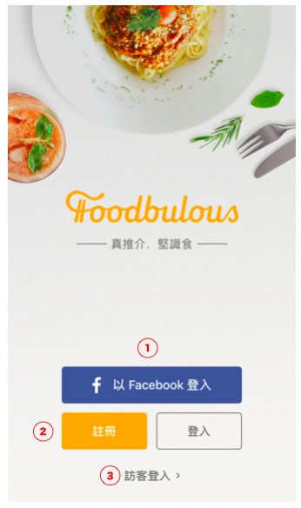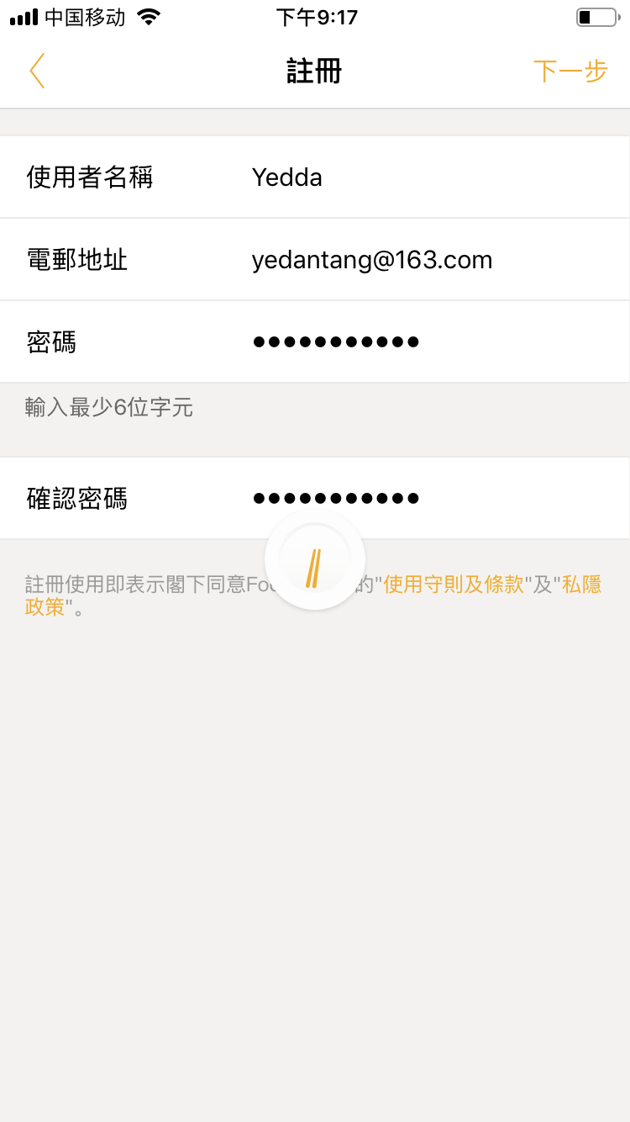
① Login with Facebook: Automated log in with facebook, without requiring filling in emails or other information. User’s Facebook friends list will be copied into the app.
② Link to the sign up page. Require to fill in user’s email.
③ Visitors. In current version, there is no obvious difference between visitor and signed-up users’ experience.
2) News Feed Page(動態消息): Food reviews posted by the people one is following
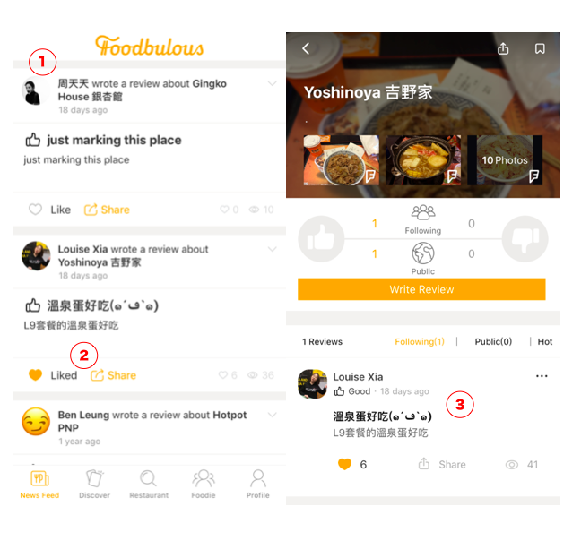
① Reviews of users’ friends will be shown on the top
② In the latest app version, users can like or share others’ posts, but they can’t make comments or reply
③ Each post links to the restaurant’s single page thta contains this piece of food review.
3)Discover Page(探索): Theme-based Restaurant Searching System
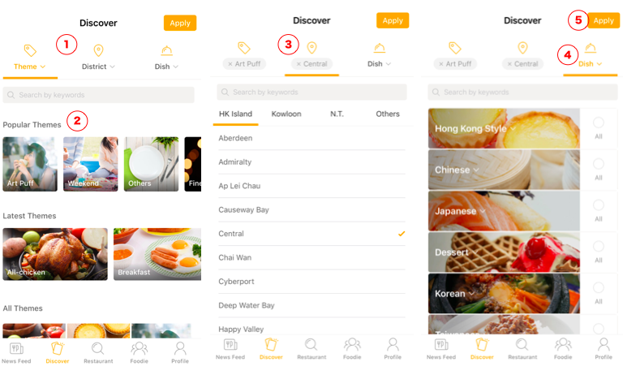
① There are Three filters on this page: theme, district and dish.
② Theme filter contains theme cards for different eating scenarios and restaurant styles, such as: restaurant for dating, for weekend parties and for eating with families.
③ District filter contains restaurants in different district blocks.
④ Dish filter contains restaurants that serve different types of dishes.
⑤ After choosing by the three filters, users can click on the “apply” button to pick out the restaurants that meet all their requirements.
4)Restaurant Page (搜尋餐廳): Direct Search of restaurants
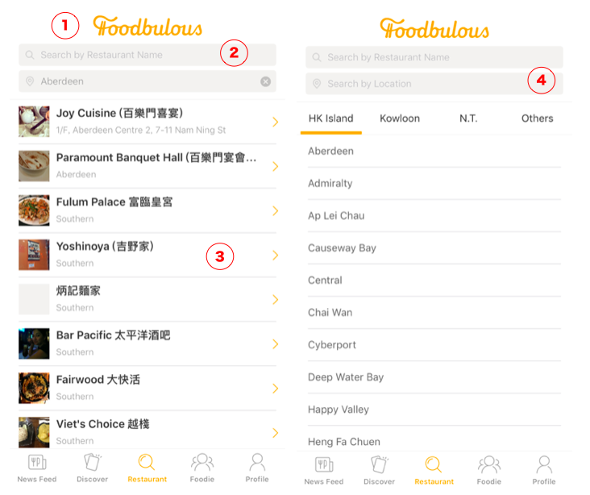

① Two direct search bars: search by restaurant name & search by location
② When searching by restaurant name, all close results will be listed.
③ Each result record contains the restaurant name and address, but there is no information on its price or food type.
④ When searching by location, user can choose restaurants according to their location districts.

5) Restaurant Single Page: Single page for one specific restaurant
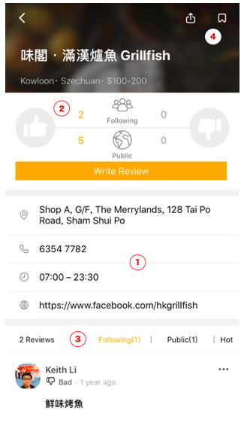

① Basic information of the restaurant
② Rating system:
— Not five star rating system, only like(thumb up) and dislike(thumb down)
— Two channels: Friends’ and Public ‘s rating
③ Reviews: reviews are displayed in three channels: friends, pubic and hot reviews. Friends’ reviews are shown first.
④ User can click on the stamp button in the top right corner of the screen to collect this restaurant into their decks

6)Foodie Page(食家): Showing a list of users one can follow on Foodbulous.
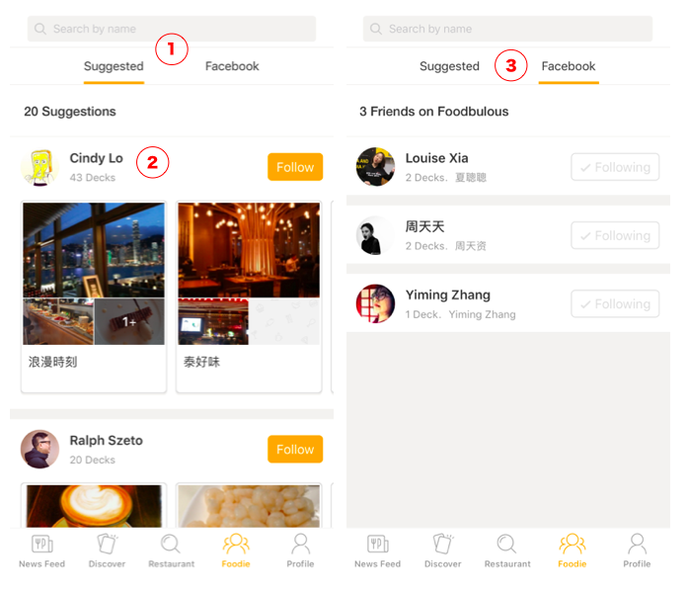
①The foodies(users) are divided in two groups:
－－－suggested strangers & automated loaded-in Facebook friends
② A group of Decks（食組）are shown on each user’s record, which is in fact their favorite restaurant collection folder.
③ Users who log in with Facebook will see their Facebook friends that also use Foodbulous.
7) Profile Page (我的食鑑)： User’s own profile page
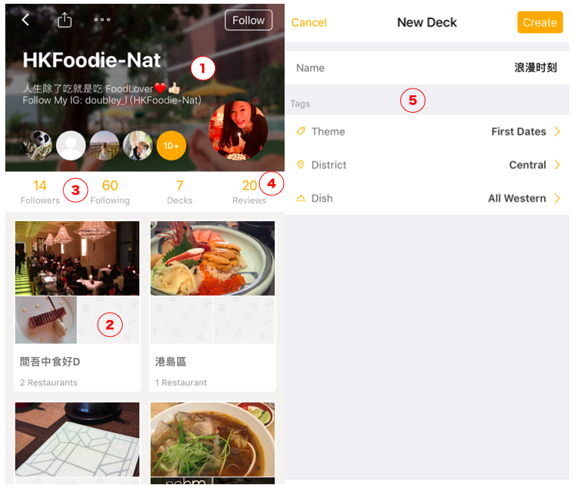
① User’s name and status
② User’s favorite decks of restaurants
③ Link to User’s following and followers’ lists
④ Link to User’s food review
⑤ User can build, name their desks and tag them with different labels of theme, district and dish.

3.5 Current Business Model:

According to Keith, they want to solve the problem of too many fake reviews (people being paid to promote certain restaurants and badmouth their competitors) and advertisements on OpenRice, so they won’t take any advertisements from restaurants.

However, they are open to advertisements from other business related to the catering industry, such as credit cards, food ingredients and kitchenware, which might become their future revenue source.

4. PROBLEMS — with UX elements paradigm

UX elements |  | Problems
The Strategy Plane | Site Objectives | Foodbulous seems to have many functions but none of them is outstanding enough to make the product distinguishable.  Reason: The team members fail to reach a consensus before design the app.
The Strategy Plane | User Needs | - Fail to identify the target users before design the app.  - Although the team identify the user pain points as mentioned before, they were not clear about what problems they want to solve and how to solve.
The Scope Plane | Functional Specifications | - The objectives of each functions are not specific.  - Too many functions can distract the users.  - The relations between the functions are not very clear.
The Scope Plane | Content Requirements | - Lack of data of the restaurants.  First, The app is supposed to contain most of the restaurants in HK, however, many restaurants cannot be founded after our testing.  Second, After applying all the conditions in the “discovery” functions, it turns out nothing in most cases. It can be implied that the data is not enough to support all the filters.  - Lack of data of the users. Keith mentioned a great regret that the app did not designed a place to collect the data from the users, especially the emails. So it is hard for Foodbulous backend to analyse the users and develop marketing campaign.  - At the very beginning, an app needs a long time to precipitate users, so the designers themselves need to provide more content to make the app looks “rich”. However, the official account just present a little information, which make the app looks “lean”.
The Structure Plane | Interaction Design | - Some interactions are not reasonable.  Landing page: the default landing page is the “Moments” where show the users’ friends posts. But for the first users (who have not followed any friends), the page is totally blank without any reminders or buttons to call actions.  Discovery: after click the button, the users expect to see the restaurants directly. But in Foodbulous, the users have to click the button on the tight-top to “apply” the conditions.  - Usually flashback (suddenly end the program when the user acted frequently)
The Structure Plane | Information Architecture | The categories of food are unclear and not attractive. It is hard for users to guess the real meaning just for the name such as 「是但啦」/「极邪恶」,etc
The Skeleton Plane | Interface Design/Navigation Design | - No “comments” function. According to Keith, one of the most important features of Foodbulous is to let users share good food with their friends. Now Foodbulous only allow people to “like” and “repost” but we think “reply” is also initial to social networking.  - Since the basic logic and user journey behind the app is not clear at the very beginning, without effective navigation, it is harder for users to know their position during the process
The Skeleton Plane | Information Design | The secondary list of 「菜式」is missing
The Skeleton Plane | The Surface Plane - Visual Design | Most of the pictures are low-quality and unattractive. The quality of food pictures is very important for a food app to maintain the users and attract new users.

5. OBJECTIVE
To improve the usability of Foodbulous
To increase the downloads and the number of users

- STRATEGY & SOLUTION
6.1 UX Redesign
To make Foodbulous easy to use, our team plan to redesign the workflow of every section based on user journey. By focusing on “food review” part, we plan to build up the bridge between users and restaurants.
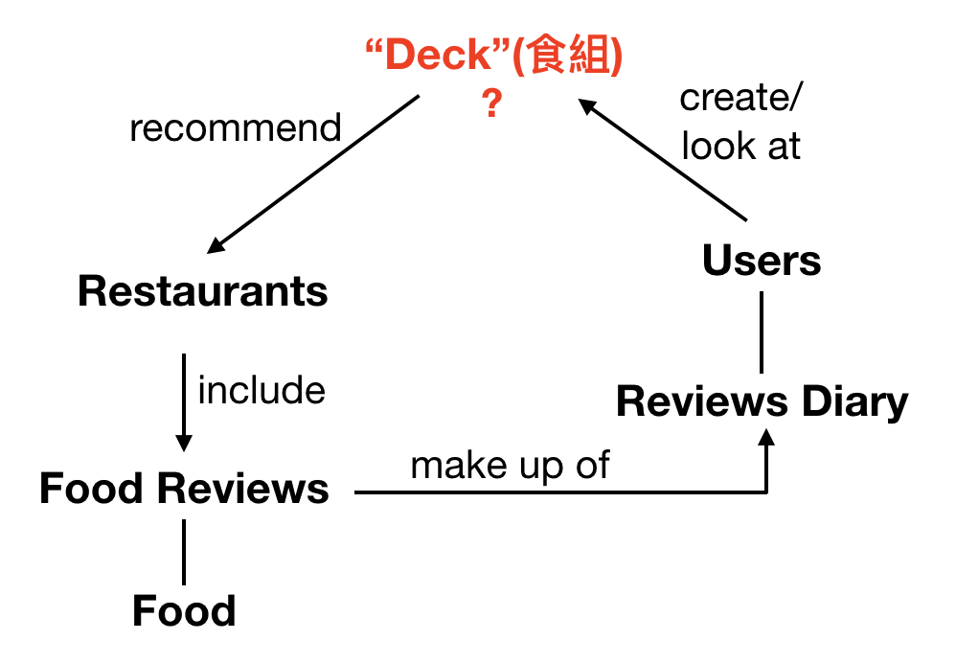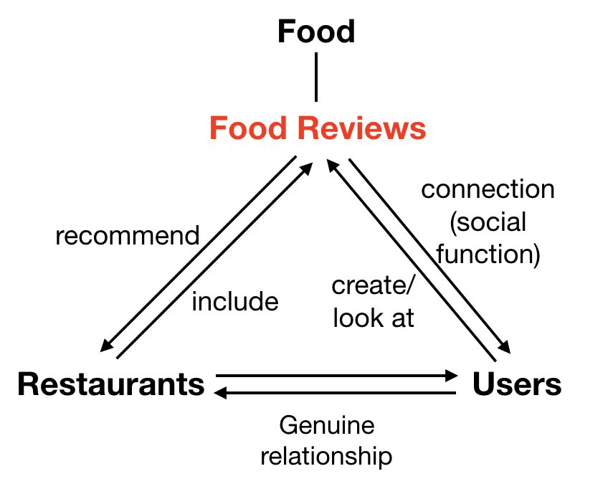
Current UX Revised UX

- For food seekers (normal users):
search for food or restaurant → see food reviews → find relevant food, restaurants, favorites → discover and mark good food → discuss with reviewers and other foodies
- For food review writers (potential KOLs):
write remarks, upload photos, rate the food → publish food reviews → categorize to favorites → discuss with other foodies

6.2 UI Redesign
The new UI will be grounded on our App objective and attempts to facilitate the user journey by improving the old version in the following three dimensions:
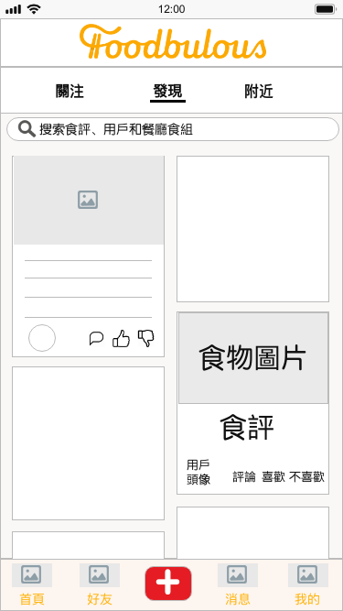
New UI Sample (Prototype) Current UI

1) To enhance the social and community attribute of Foodbulous
--- By placing user-generated food and/or restaurant Reviews (食評) on the Homepage with big and fantastic pictures;
--- By introducing “comment”, “like” and “dislike” functions to each Food Review to increase interactivity between users;
--- By enabling users to store, like, comment others’ Decks (食組) and share them to other social media platforms;

2) To improve usability of Foodbulous and increase user’s agency
--- By displaying “Writing Reviews (寫食評)” in a conspicuous place (i.e. navigation bar at the bottom), where users can easily find once they want to post Notes;
--- By replacing ambiguous wordings (e.g. “空腹食早餐”, “男人的浪漫”, “偉大的媽媽”...) with more explicit and directed ones to avoid confusion;
--- By transforming “Restaurant (搜索餐廳)” tab to a multipurpose search bar, which is fixed at the top of every tab page;
--- By integrating “Popular Themes (卡牌)” into search bar as tag suggestions (標籤聯想提示) with reference to 小紅書, and offering Autocomplete Suggestions with reference to Google
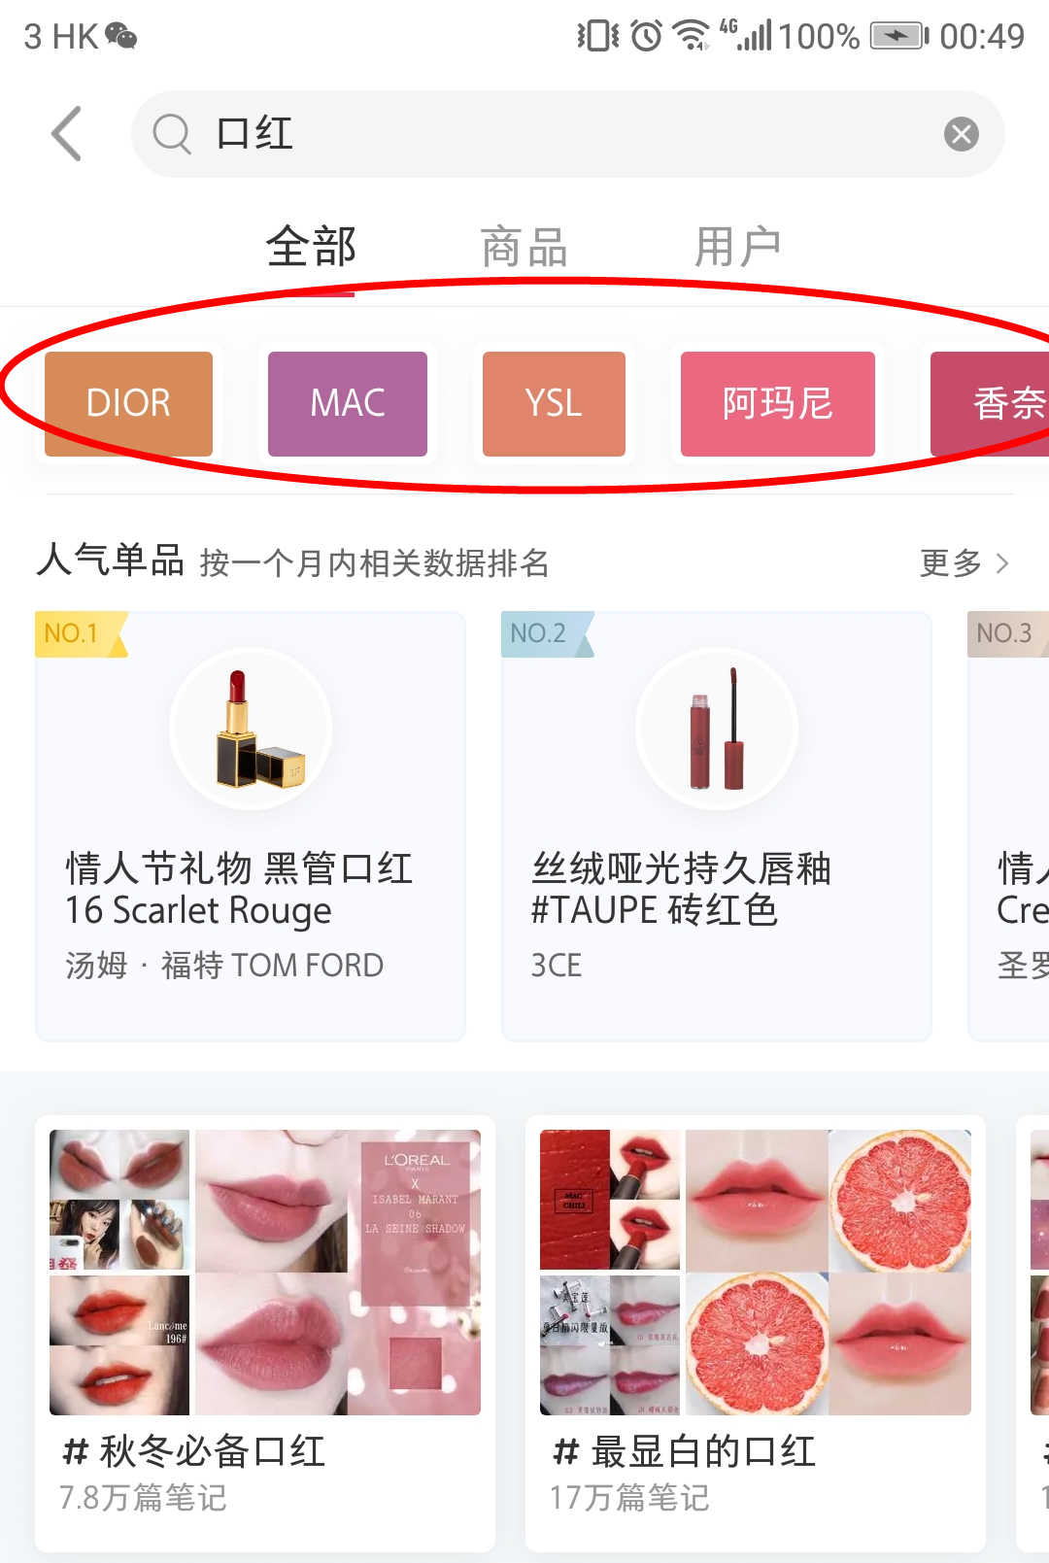
小紅書Tag suggestions
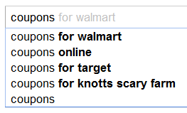
Google Autocomplete Suggestions
3) To strengthen the relationship between product (i.e App) and users
--- By adding more methods for logging in in addition to Facebook (e.g. Whatsapp, Instagram)
--- By creating sharable QR code and URL for users to invite their friends

6.3 Customer Redefine
Segemnt | Origin | Eating Style | How to find restaurant | Income | Marital status | Gender | Age
1 | Local | eat at home | friend recommend | Low-income | single | male | below 13
2 | PRC | eat in | Internet search | Middle-class | couple | female | 13~18
3 | Foreign | take away | restaurant finding App | Elite | family |  | 19~35
4 |  |  | walk in |  | separated |  | 36~50
5 |  |  | flyer/menu |  |  |  | over 50
6
7

- TESTING & EVALUATION
7.1 KPIs
We have set several KPIs to evaluate the success of our UI/UX redesign
- 1. Downloads
- 2. Review Scores gained
- 3. DAU

7.2 Usability test; A/B test
According to Keith, the redesigned products cannot be online immediately. So large-scale A/B test is difficult to carry out, and Keith believes that small-scale A/B test is meaningless. So in the testing phase, we will focus more on usability test.

Two measurement methods:
- scenario metrics
- experience scorecards
Three steps:
- Step 1: the wireframe will be printed on paper and the redesigned app will be simulated by cropping, pasting, and coloring.
- Step 2: some users will be invited to experience the app. And they will be placed in some scenarios, such as “write a review for Chan Kun Kee” or “find a delicious Italian restaurant”. In the process, their behavior will be recorded by video and will be measured and scored.
- Step 3: all the scores will be recorded in scorecards and the scores will be updated as the design is iterated. After the entire project is completed, the trendline can be drawn based on the score.

7.3 Qualitative Research: Face-to-face Interview
1) Objectives: understand the attitudes or mind-sets of a user, by asking for the “Why” and “How”.
2) Plan: deliver an interview with 5 people after every version of interactive prototype.

8. TIMELINE
8.1 Breakdown
Agile development method will be applied in order to keep moving through
and collect important feedback from the sponsor and user testing as guidance for iterations.
To clarify, the Foodbulous project differs from real agile development processes in that Foodbulous will not be released to real users, and the equivalent of product releases will be our prototype deliverables to the sponsor. Our team has confirmed with Keith that there will be two more meetings during the whole project period, so we decided to divide the whole process into three iteration cycles and present to him two deliverables for feedback.
- In the first sprint, a lo-fi prototype with interface wireframes of all app sections will be built and used to conduct usability test. The goal for the first sprint is to address the usability issues and verify whether our objectives can be achieved with the redesigned and reorganized features of Foodbulous.
- The second sprint will include a hi-fi prototype with interactions added and features improved according to the feedback from the last sprint. A second usability test will also be carried out during the corresponding review phase for more tweaks in UI/UX of the third sprint.
- The timescale of the third sprint will be shorter with final adjustments to wrap up the revamped UI/UX set.

Our project timeline throughout the whole semester would be as follow:
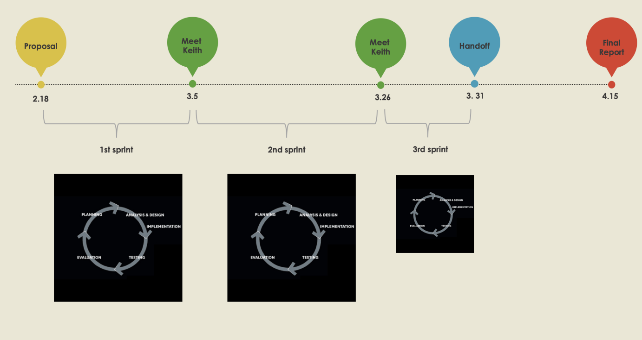

For the next step, our team is going to utilize user story mapping techniques to groom our backlog and prioritize the features. After dividing the user stories into chunks of sprints, we can kick off our first sprint cycle.

8.2 Project Management Tracking
Please click here to check our project management Airtable page.

9. MARKETING
Due to lack of manpower of Innopage, the revamp project will remain experimental without going into the real market this time. However, according to our research and previous meeting with Keith, Foodbulous’ marketing practices so far include media exposure before 2017 and some small offline campaigns that showed limited effect of user growth. Therefore, it would be very meaningful that we still provide a follow-up marketing plan for Foodbulous’ possible relaunch in the future.

Digital marketing approaches in the course outline can be applied to Foodbulous’ case. For example, currently Foodbulous does not have any contact info of the real users. The bond can be enhanced in the future through CRM and email marketing. Also, Foodbulous runs an official Facebook account, and we can rejuvenite its influence and generate more traffic using content marketing practices.

Specific approaches will be discussed in the future report.

